|  |
| --- |
| [Type the company name] |
| Setting Up Firewall |
| Windows Server 2008 R2 Enterprise – 64bit |

# Setting up Windows Firewall

* 1. Setting up Inbound Rule to allow port “**8090**”
     1. Click on **Start >> Control Panel**

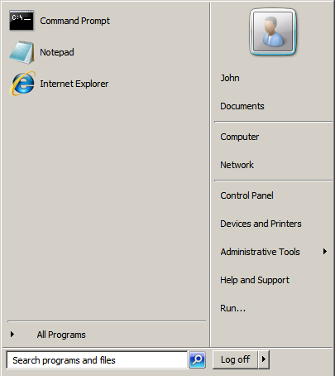

Figure 1: Start Menu

* + 1. Click on “**Windows Firewall**”

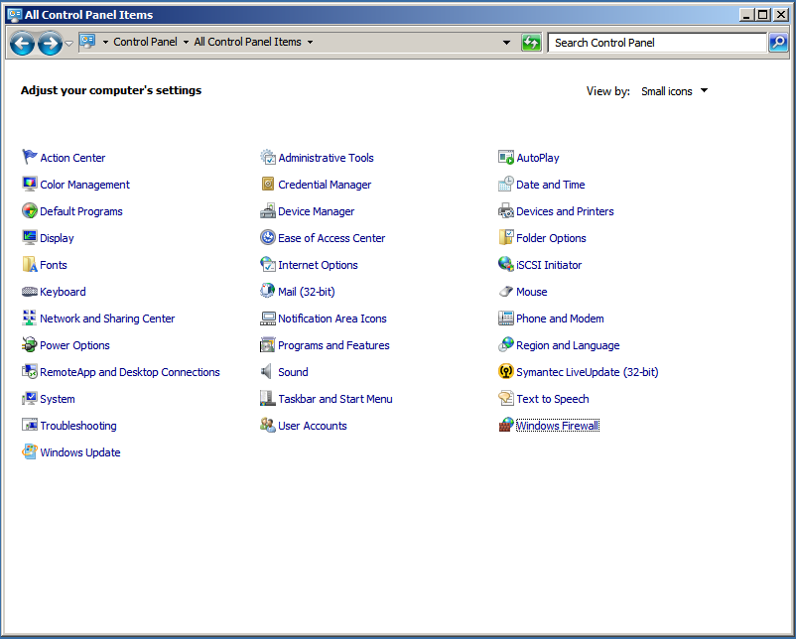

Figure 2: Control Panel

* + 1. Click on “**Advanced Settings**”

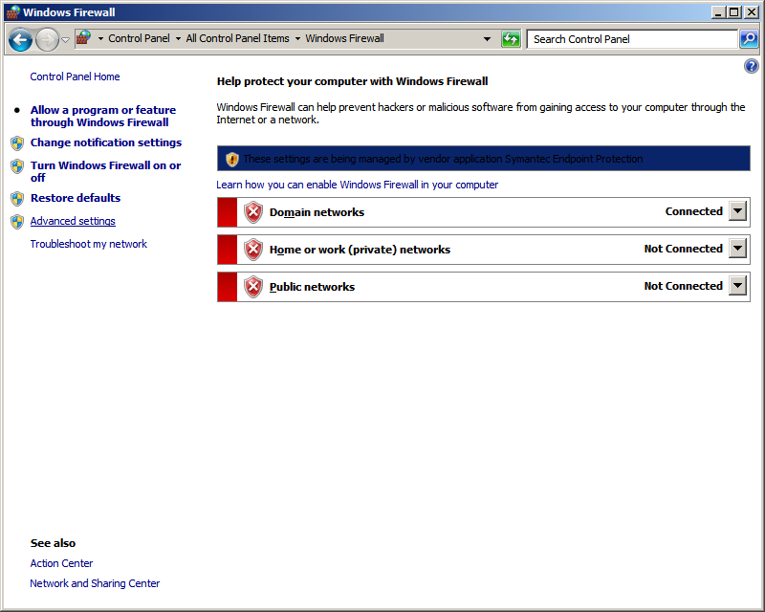

Figure 3: Advanced Settings

* + 1. Click on “**Inbound Rules**”
    2. Click on “**New Rule…**”

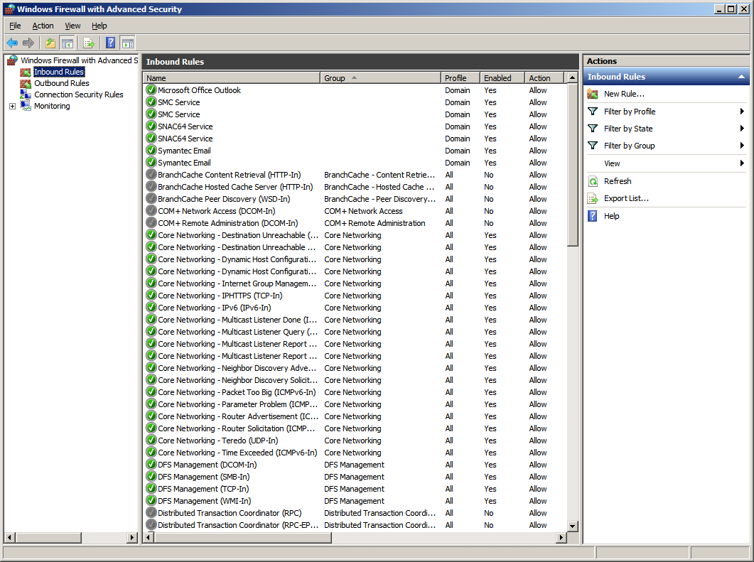

Figure 4: Inbound Rules

* + 1. Click on “**Port**”
    2. Click on “**Next >**”

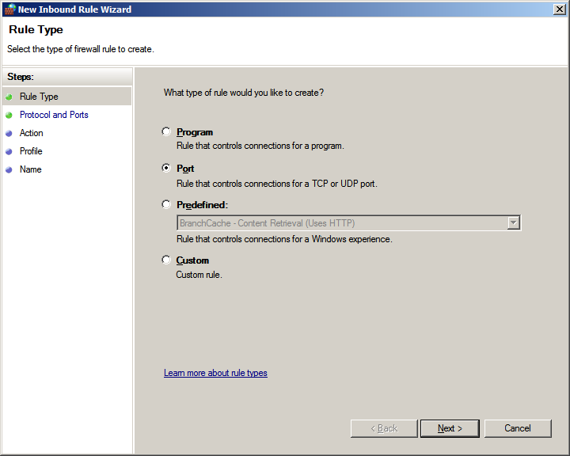

Figure 5: New Inbound Rule for "Port" setting

* + 1. Ensure that “**TCP**” is selected by default, if not please select “**TCP**”
    2. Select “**Specific local Ports**”
    3. Enter “**8090**”
    4. Click on “**Next >**”

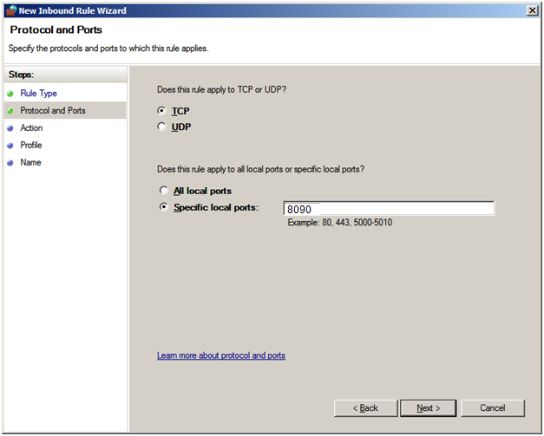

By default, In AccountingPlus Software, windows service named “**PrintJobListenerService**” uses port **8090**.

To configure other than “8090”, ***Please refer admin guide for custom port configuration***

**TCP** is selected by default. **Please don’t change it**

Figure 6: Protocol and Ports

***Note:***

1. AccountingPlus Software uses port **8090** to listen network stream on TCP for print jobs.
2. You can configure this port to any other unused port.
   * 1. Keep the defaults and Click on “**Next >**”

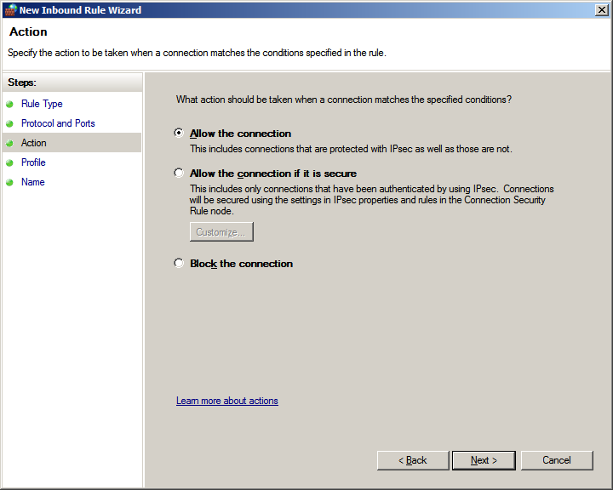

Figure 7: Allow the connection

* + 1. Keep the defaults and Click on “**Next >**”

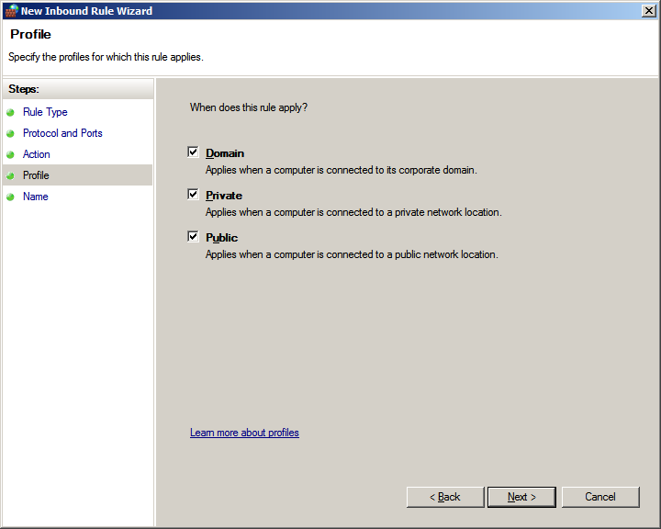

Figure 8: Profile settings

* + 1. Enter “**AccountingPlus Software inbound rule**” in the “**Name**” text field
    2. Enter “**AccountingPlus Software inbound rule to allow port 8090 to listen network stream on TCP**” in the “**Description (optional)**” text field
    3. Click on “**Finish**”

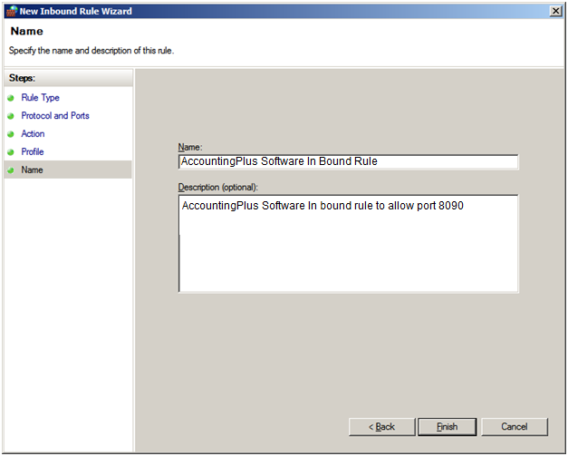**Figure 9: Name Setting**

* + 1. Ensure that “**AccountingPlus Software inbound rule**” is configured

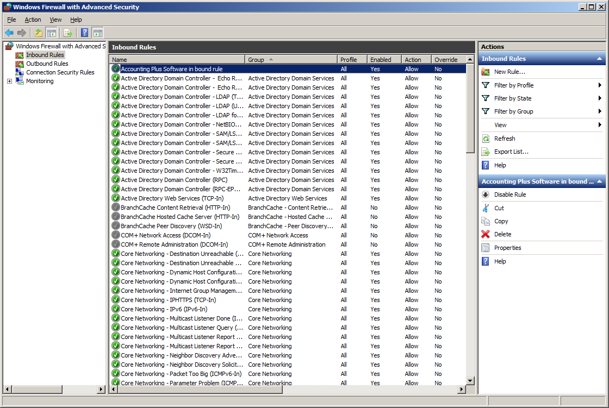

Figure 10: Accounting plus Software inbound rule

* 1. Setting up Outbound Rule to allow port “**8090**”
     1. Click on “**Outbound Rules**”
     2. Click on “**New Rule**”

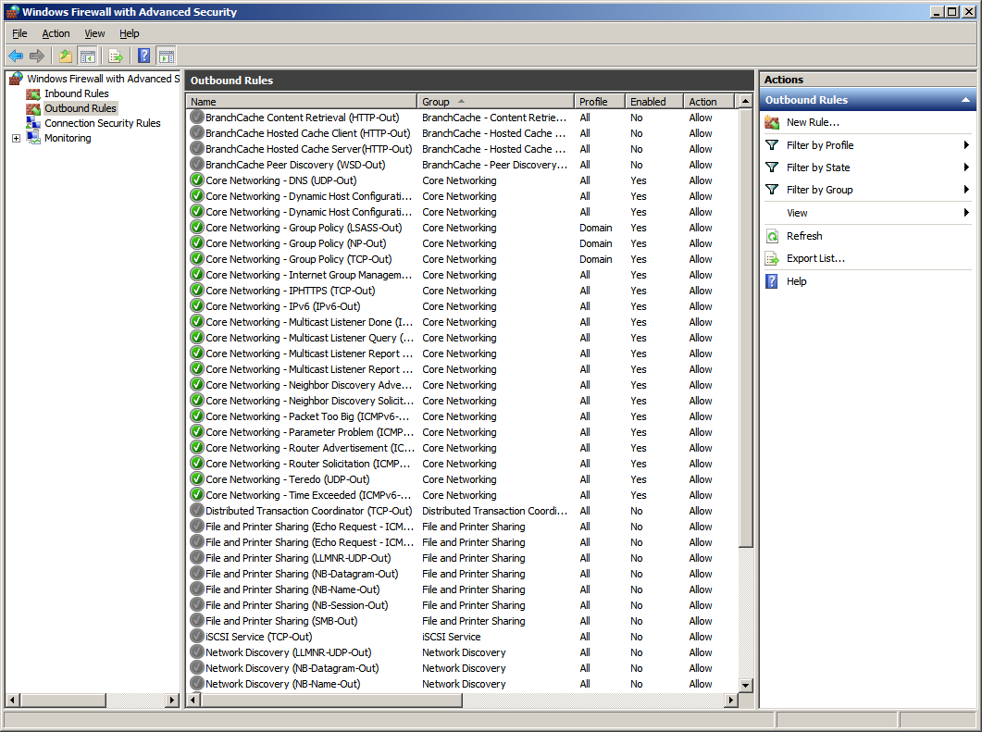

Figure 11: Outbound Rules

* + 1. Click on “**Port**”
    2. Click on “**Next** **>**”

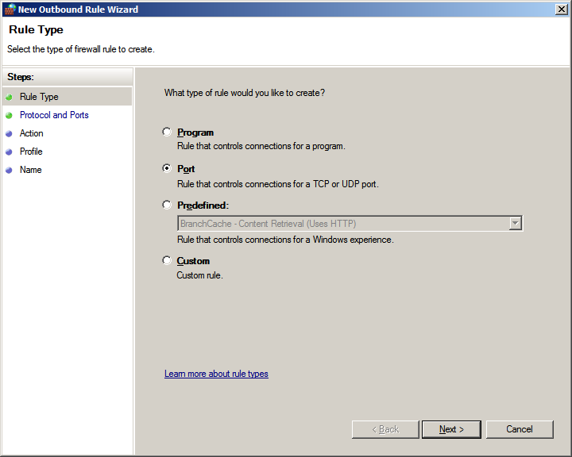

Figure 12: New Outbound Rule ["Port"]

* + 1. Ensure that “**TCP**” is selected by default, if not please select “**TCP**”
    2. Select “**Specific remote Ports**”
    3. Enter “**8090**”
    4. Click on “**Next >**”

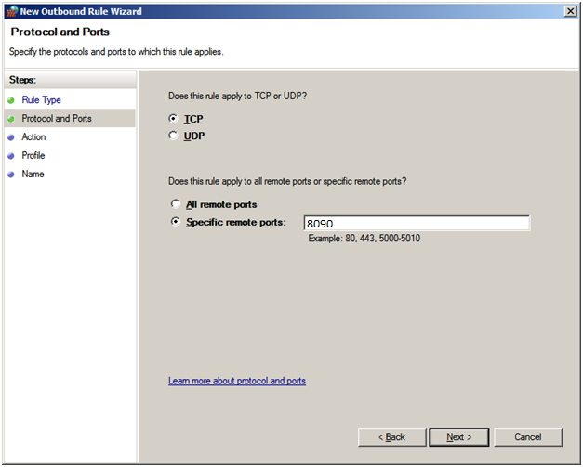

By default, In Accounting plus Software, windows service named “**PrintJobListenerService**” uses port **8090**.

To configure other than “8090”, ***Please refer*** ***section 7 on page 67*** ***for custom port configuration***

**TCP** is selected by default. **Please don’t change it**

Figure 13: Protocol and Ports

***Note:***

1. Please enter same port number as entered while configuring “Inbound Rule”.
2. Accounting Plus uses port **8090** tolisten network stream on TCP for print jobs.
3. You can configure this port to any other unused port.
   * 1. Select “**Allow the connection**”
     2. Select **“Allow the connection” radiobutton.**
     3. Click on “**Next >**”

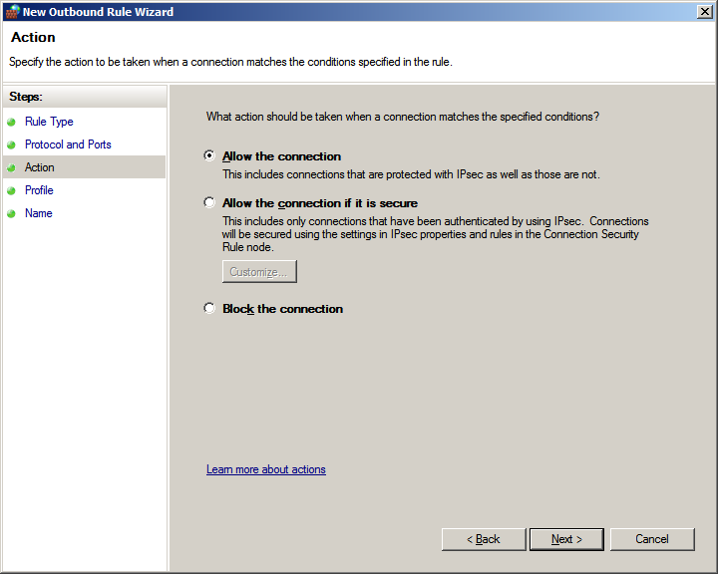

Figure 14: Allow connection

* + 1. Keep the defaults and Click on “**Next >**”

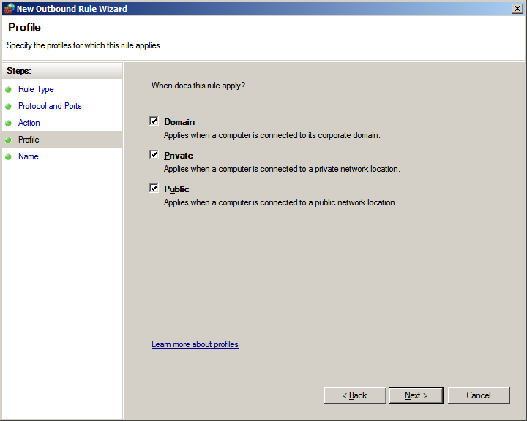

Figure 15: Profile

* + 1. Enter “**Accounting Plus Software outbound rule**” in the “**Name**” text field
    2. Enter “**Accounting Plus Software** **outbound rule to allow port 8090 to listen network stream on TCP**” in the “**Description (optional)**” text field
    3. Click on “**Finish**”

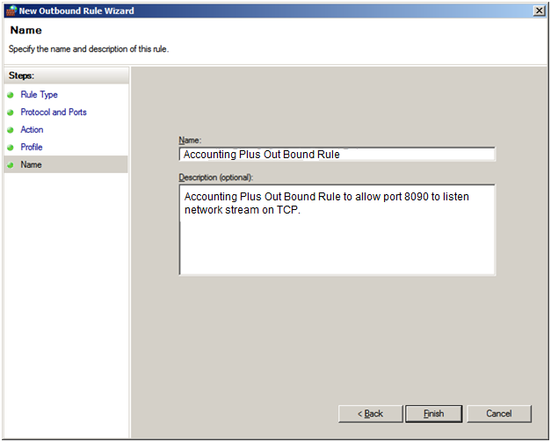

Figure 16: Accounting plus Software Outbound Rule

* + 1. Ensure that Accounting Software outbound rule is created successfully.

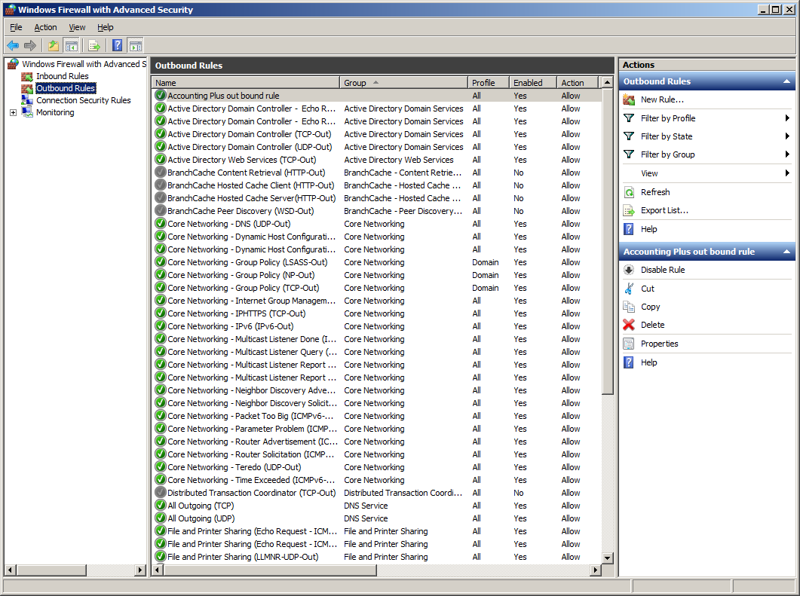

Figure 17: Sharp Accounting plus Software outbound rule

* 1. Enabling Inbound Rule of “**World Wide Web Services (HTTP Traffic-in)**” to allow port “**80**”
     1. Click **Start**, and then click **Control Panel**
     2. Click “**Windows Firewall**”
     3. Click “**Advanced Settings**”
     4. Click “**Inbound Rules**”
     5. Select “**World Wide Web Services (HTTP Traffic-in)**” inbound rule
     6. Make sure that the rule is in Enable state else click “**Enable Rule**”

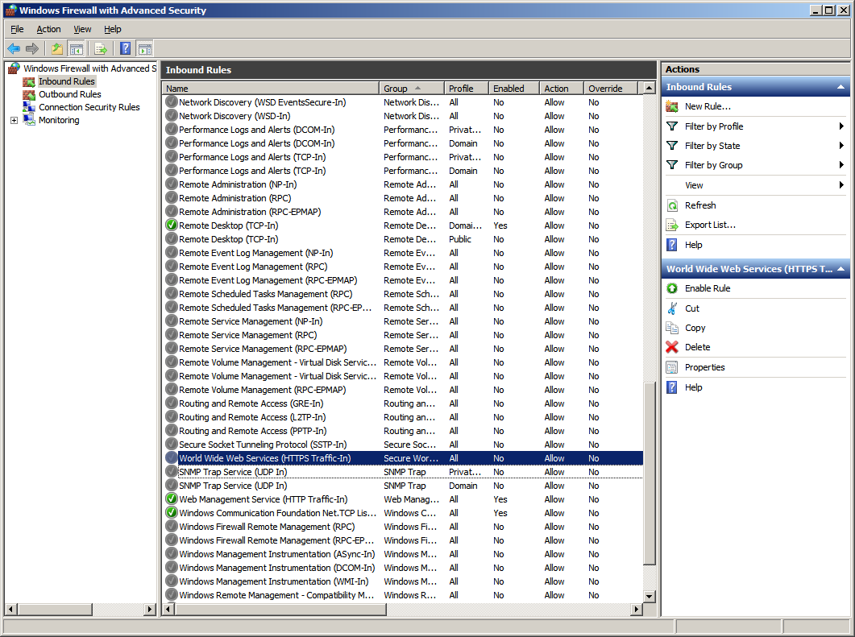

Figure 18: World Wide Web Services (HTTP Traffic-in)” inbound rule